
Faculty of Science

Course: CSCI 2020u – Software System Development & Integration
Component: Assignment
Weight: 10%
Deadline: March 5, 2020 (due by 11:59pm)

Collaboration Policy
You are permitted to work on this assignment in a team, and submit the results as a team. For this sort of assignment, with an open-ended component, the collaboration between multiple team members can be beneficial. Between groups, however, please limit the discussion to the level of general strategy (not code). Groups of size 2 are recommended. Larger groups will be considered with the proviso that the marker will mark your assignment with higher expectations. In any case, be sure that all members of the team fully understand all code, otherwise they will miss intended learning objectives, which may be a considerable disadvantage at exam time.

How to Submit
You will maintain a git repository for this assignment, which is a public repository. To submit the assignment, create a single file ‘README.txt’ that contains instructions on how to download, compile, and run your codes for each question. A .zip, .7z, or .rar file will not be acceptable. Also submit this word file (once you complete) into related drop box on Blackboard before deadline.

Note: Comments are mandatory. Failure to properly document your program will result in a deduction on the marks you receive for this (and any other) assignment.

Remember:
You need to complete this file and submit it in related drop box on Blackboard, in addition to uploading your codes in your git repository, before deadline.

Question 1: Displaying Three Cards

Problem Description:
Display a frame that contains three labels. Each label displays a card, as shown in the figure below. The card image files are named 1.png, 2.png, ..., 54.png and stored in the image/card directory. All three cards are distinct and selected randomly.

The image icons can be found in the attached card folder.

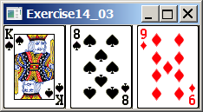

Your Task:
- Create three ImageView and set their icons using the images.
- Display three images from 54 image cards randomly.

Your Code:
Copy-paste your code here:

// Owen Reid 100694494 March 5th 2020
package sample;
import javafx.application.Application;
import javafx.scene.Scene;
import javafx.scene.layout.HBox;
import javafx.scene.layout.Pane;
import javafx.geometry.Insets;
import javafx.stage.Stage;
import javafx.scene.image.Image;
import javafx.scene.image.ImageView;
import java.util.Random;
public class Main extends Application {
@Override
public void start(Stage primaryStage) {
Pane pane = new HBox(10);
pane.setPadding(new Insets(5, 5, 5, 5));
Random rand = new Random(); // Random generator class
int rand_int1 = rand.nextInt((54 - 1) + 1) + 1; // Generates random number between 1 and 54 (bounds)
Image card1 = new Image("image/Cards/" + rand_int1 + ".png"); // Chooses card based on random number picked
pane.getChildren().add(new ImageView(card1));
int rand_int2 = rand.nextInt((54 - 1) + 1) + 1; // same as above
ImageView card2 = new ImageView("image/Cards/" + rand_int2 + ".png"); // same as above
pane.getChildren().add(card2);
int rand_int3 = rand.nextInt((54 - 1) + 1) + 1; // same as above
ImageView card3 = new ImageView("image/Cards/" + rand_int3 + ".png"); // same as above
pane.getChildren().add(card3);
Scene scene = new Scene(pane);
primaryStage.setTitle("Question #1");
primaryStage.setScene(scene);
primaryStage.show();
}
public static void main(String[] args) {
launch(args);
}
}

Screen shots:
Include two screen shots here:

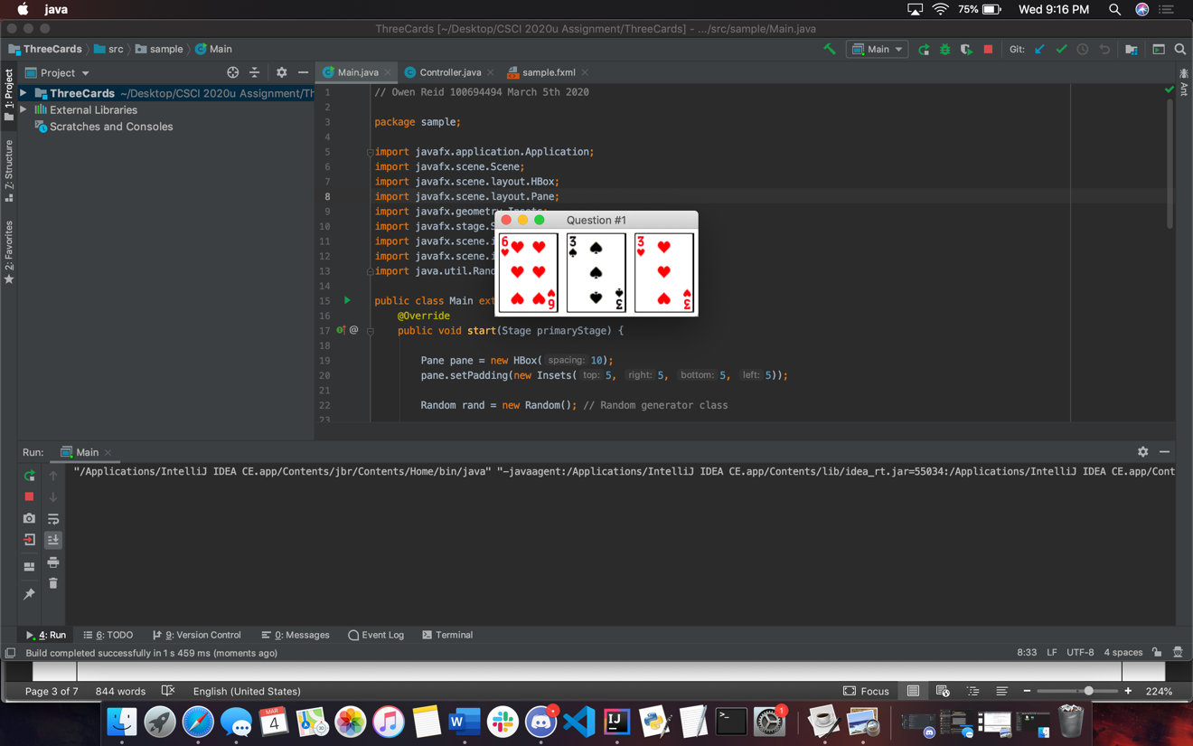

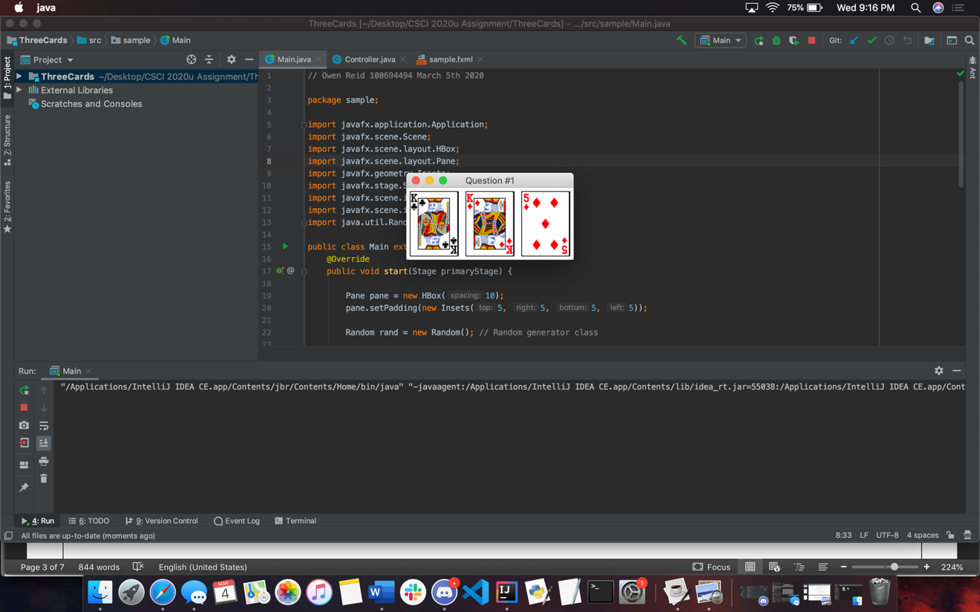

Question 2: Investment-Value calculator

Problem Description:
Write a program that calculates the future value of an investment at a given interest rate for a specified number of years. The formula for the calculation is as follows:

futureValue = investmentAmount * (1 + monthlyInterestRate)years*12

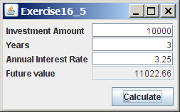

Your Task:
Use text fields for interest rate, investment amount, and years. Display the future amount in a text field when the user clicks the Calculate button, as shown in the figure.

Your Code:
Copy-paste your code here.

// Owen Reid 100694494 March 5th 2020
package sample;
import javafx.application.Application;
import javafx.geometry.HPos;
import javafx.geometry.Insets;
import javafx.geometry.Pos;
import javafx.scene.Scene;
import javafx.scene.control.Button;
import javafx.scene.control.Label;
import javafx.scene.control.TextField;
import javafx.scene.layout.GridPane;
import javafx.stage.Stage;
public class Main extends Application {
TextField invamt = new TextField(); // Set variables outside of functions to be able to use in both functions
TextField yrs = new TextField();
TextField air = new TextField();
TextField futval = new TextField();
@Override
public void start(Stage primaryStage) {
GridPane pane = new GridPane();
pane.setAlignment(Pos.CENTER);
pane.setPadding(new Insets(11.5, 12.5, 13.5, 14.5));
pane.setHgap(5.5);
pane.setVgap(5.5);
// Set lables and textfields with correct spacing
pane.add(new Label("Investment Amount"), 0, 0);
pane.add(invamt, 1, 0);
pane.add(new Label("Years"), 0, 1);
pane.add(yrs, 1, 1);
pane.add(new Label("Annual Interest Rate"), 0, 2);
pane.add(air, 1, 2);
pane.add(new Label("Future value"), 0, 3);
pane.add(futval, 1, 3);
Button btAdd = new Button("Calculate");
pane.add(btAdd, 1, 4);
GridPane.setHalignment(btAdd, HPos.RIGHT);
// Button event
btAdd.setOnAction(e -> calcFutVal());
Scene scene = new Scene(pane);
primaryStage.setTitle("ShowGridPane");
primaryStage.setScene(scene);
primaryStage.show();
}
// function to calcualte the future value of the investment using given equation
private void calcFutVal() {
double investmentAmount = Double.parseDouble(invamt.getText());
int years = Integer.parseInt(yrs.getText());
double monthlyInterestRate = Double.parseDouble(air.getText()) / 1200;
futval.setText(String.format("%.2f", investmentAmount * Math.pow(1 + monthlyInterestRate, years * 12)));
}
public static void main(String[] args) {
launch(args);
}
}

Screen shots:
Include two screen shots here:

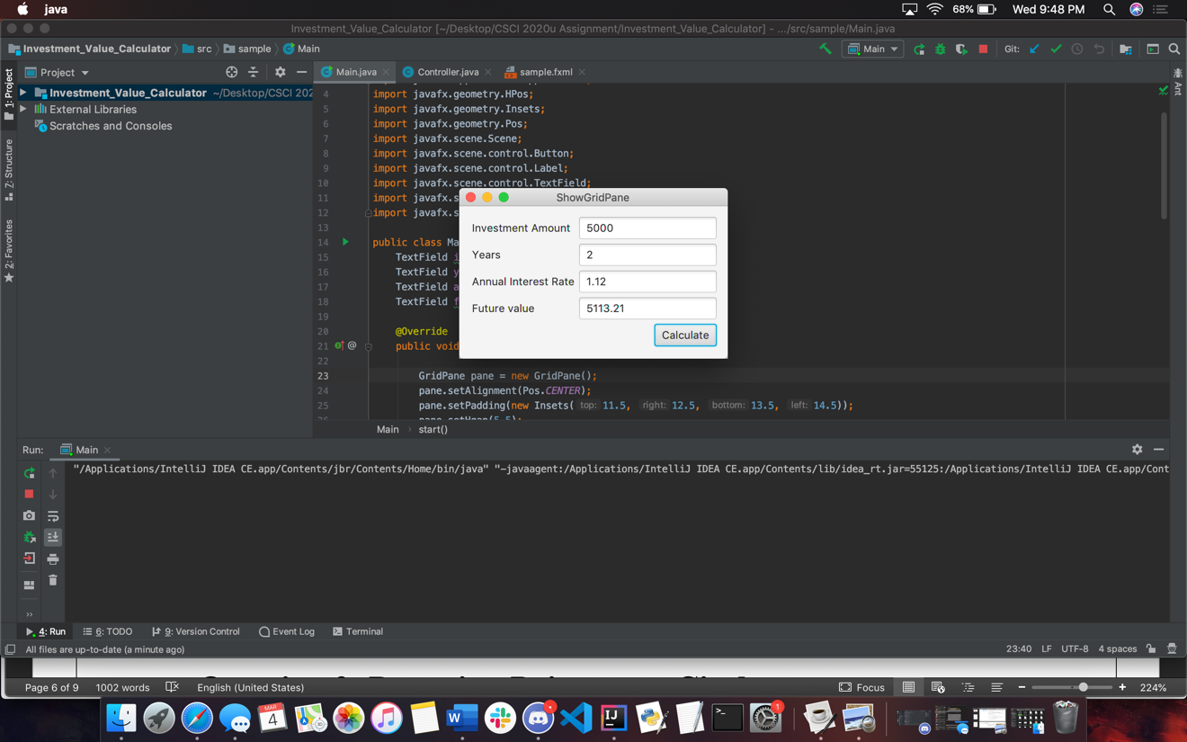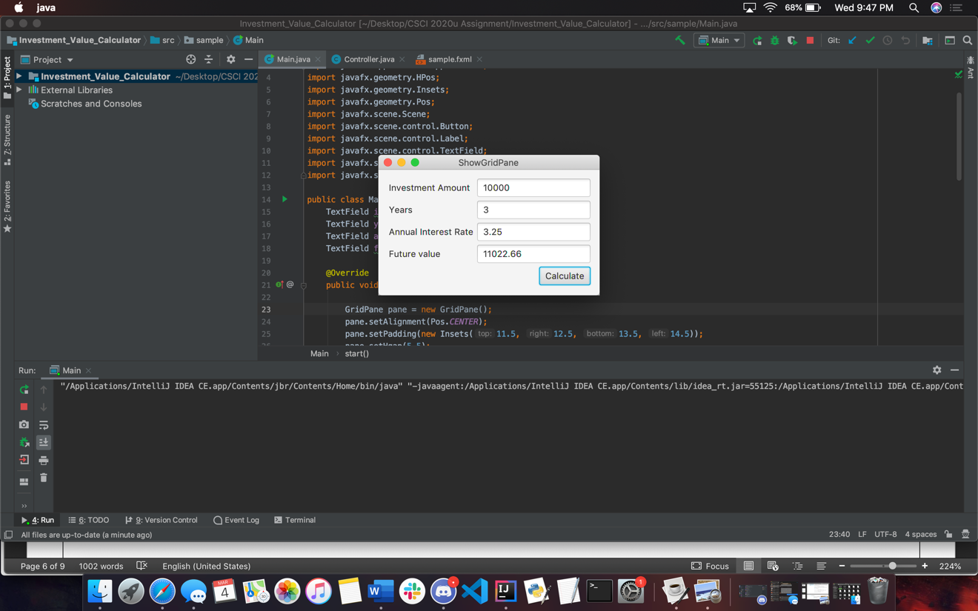

Question 3: Dragging Points on a Circle

Problem Description:
Draw a circle with three random points on the circle. Connect the points to form a triangle. Display the angles in the triangle. Use the mouse to drag a point along the perimeter of the circle. As you drag it, the triangle and angles are redisplayed dynamically.

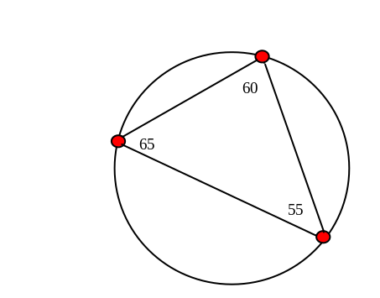

Here is the formula to compute angles:

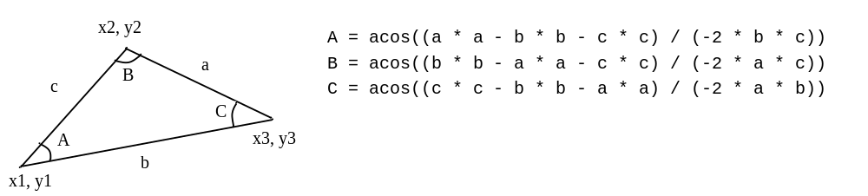

Your Code:
Copy-paste your code here:

// Owen Reid 100694494 March 5th 2020
package sample;
import javafx.application.Application;
import javafx.scene.Scene;
import javafx.scene.layout.Pane;
import javafx.scene.paint.Color;
import javafx.scene.shape.Circle;
import javafx.scene.shape.Line;
import javafx.scene.text.Text;
import javafx.stage.Stage;
public class Main extends Application {
@Override
public void start(Stage primaryStage) {
Pane pane = new Pane();
Circle circ = new Circle(100, 100, 75); // intial circle
pane.getChildren().add(circ);
circ.setFill(Color.TRANSPARENT);
circ.setStroke(Color.BLACK);
Circle[] points = new Circle[3]; // array of points on circle
Line[] lines = new Line[3]; // array of lines connected to points (creates angles)
Text[] texts = new Text[3]; // array of the degrees that will be shown next to points
for (int i = 0; i < points.length; i++) { // loops over created arrays to create the objects
texts[i] = new Text();
points[i] = new Circle(0, 0, 5); // intial points size
points[i].setStroke(Color.BLACK);
points[i].setFill(Color.RED);
final int index = i; // the variable used in lambda expression below must be final
points[i].setOnMouseDragged(e -> { // mouse event action to move the points around thus creating new angles
double radian = Math.atan2(e.getY() - circ.getCenterY(), e.getX() - circ.getCenterX());
double x = circ.getCenterX() + circ.getRadius() * Math.cos(radian);
double y = circ.getCenterY() + circ.getRadius() * Math.sin(radian);
points[index].setCenterX(x);
points[index].setCenterY(y);
moveThePoints(lines, points, texts);
});
}
// this creates the angles at predetirmined spots on the circle,
// uses equations to convert angles into proper degrees
double angle = 180;
double x = circ.getCenterX() + circ.getRadius() * Math.cos(Math.toRadians(angle));
double y = circ.getCenterY() + circ.getRadius() * Math.sin(Math.toRadians(angle));
double angle1 = 280;
double x1 = circ.getCenterX() + circ.getRadius() * Math.cos(Math.toRadians(angle1));
double y1 = circ.getCenterY() + circ.getRadius() * Math.sin(Math.toRadians(angle1));
double angle2 = 20;
double x2 = circ.getCenterX() + circ.getRadius() * Math.cos(Math.toRadians(angle2));
double y2 = circ.getCenterY() + circ.getRadius() * Math.sin(Math.toRadians(angle2));
// sets the points
points[0].setCenterX(x);
points[0].setCenterY(y);
points[1].setCenterX(x1);
points[1].setCenterY(y1);
points[2].setCenterX(x2);
points[2].setCenterY(y2);
// creats the lines
for (int i = 0; i < lines.length; i++) {
int cIndex2 = (i + 1 >= points.length) ? 0 : i + 1;
lines[i] = new Line(
points[i].getCenterX(), points[i].getCenterY(),
points[cIndex2].getCenterX(), points[cIndex2].getCenterY());
}
moveThePoints(lines, points, texts);
pane.getChildren().addAll(lines);
pane.getChildren().addAll(texts);
pane.getChildren().addAll(points);
primaryStage.setScene(new Scene(pane, 200, 200));
primaryStage.setTitle("Question 3");
primaryStage.show();
}
// This function allows for the points to be moved with the lines reacting to the point movement
private void moveThePoints(Line[] line, Circle[] point, Text[] angles) {
for (int i = 0; i < line.length; i++) {
int cIndex2 = (i + 1 >= point.length) ? 0 : i + 1;
line[i].setStartX(point[i].getCenterX());
line[i].setStartY(point[i].getCenterY());
line[i].setEndX(point[cIndex2].getCenterX());
line[i].setEndY(point[cIndex2].getCenterY());
angles[i].setX(point[i].getCenterX() + 5);
angles[i].setY(point[i].getCenterY() - 5);
}
// uses equation given in question to display the angle on the point after being moved
double a = Math.sqrt((line[0].getStartX() - line[0].getEndX()) * (line[0].getStartX() - line[0].getEndX()) +
(line[0].getStartY() - line[0].getEndY()) * (line[0].getStartY() - line[0].getEndY()));
double b = Math.sqrt((line[1].getStartX() - line[1].getEndX()) * (line[1].getStartX() - line[1].getEndX()) +
(line[1].getStartY() - line[1].getEndY()) * (line[1].getStartY() - line[1].getEndY()));
double c = Math.sqrt((line[2].getStartX() - line[2].getEndX()) * (line[2].getStartX() - line[2].getEndX()) +
(line[2].getStartY() - line[2].getEndY()) * (line[2].getStartY() - line[2].getEndY()));
double A = Math.toDegrees(Math.acos((a * a - b * b - c * c) / (-2 * b * c)));
angles[0].setText(String.format("%.0f", A));
double B = Math.toDegrees(Math.acos((b * b - a * a - c * c) / (-2 * a * c)));
angles[1].setText(String.format("%.0f", B));
double C = Math.toDegrees(Math.acos((c * c - b * b - a * a) / (-2 * a * b)));
angles[2].setText(String.format("%.0f", C));
}
public static void main(String[] args) {
Application.launch(args);
}
}

Screen shots:
Include two screen shots here:

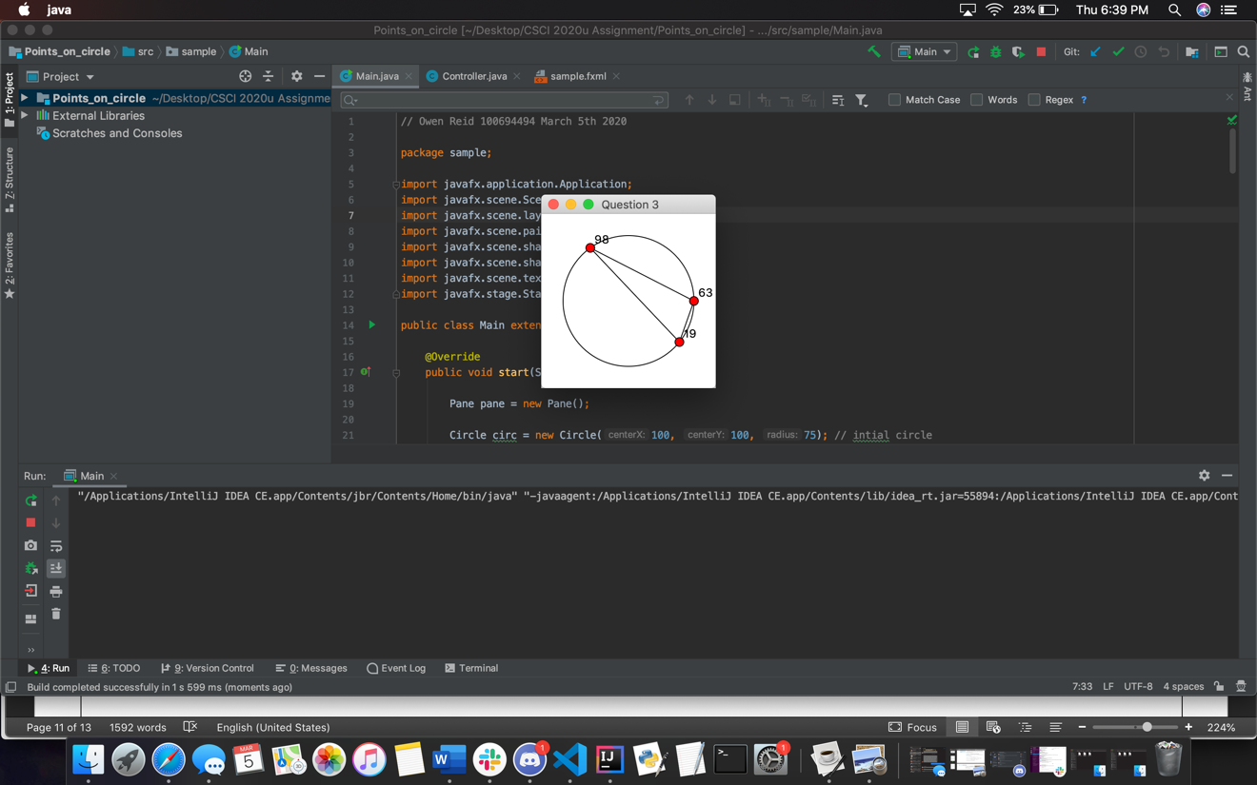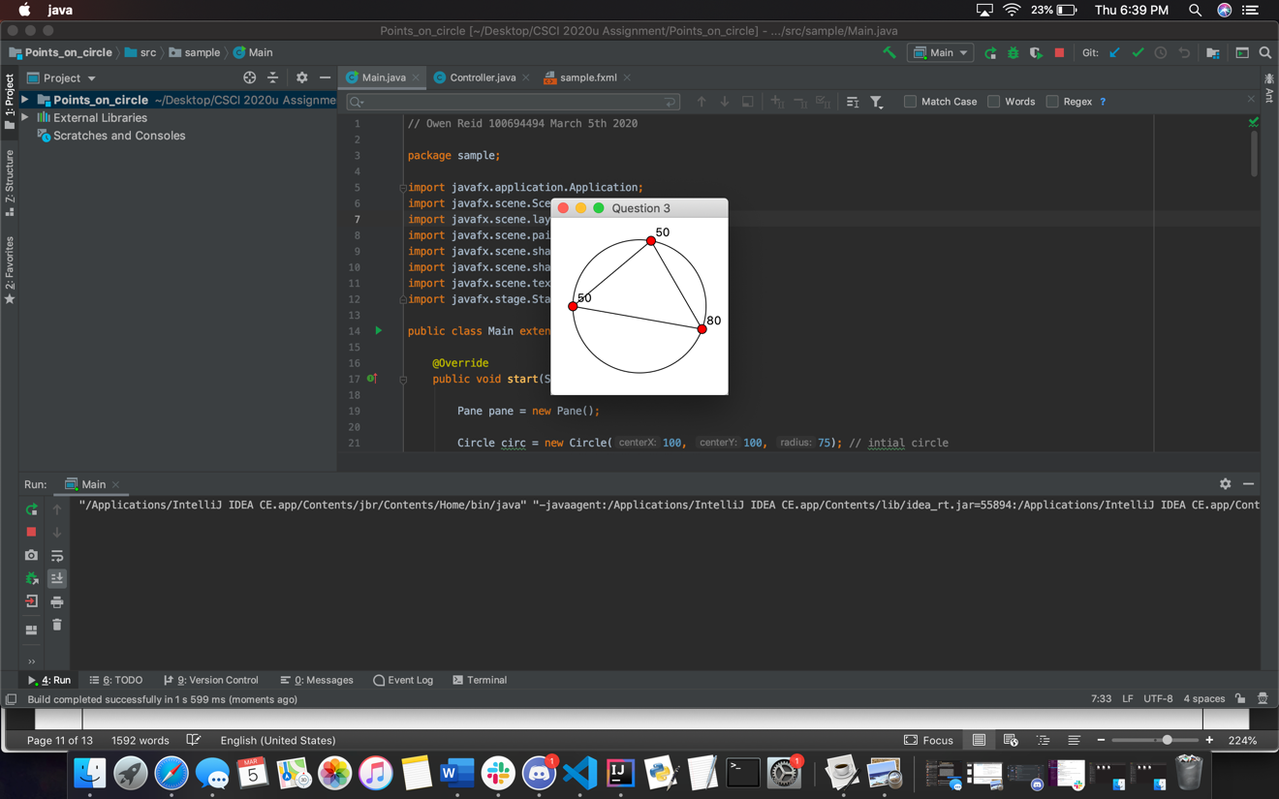
Question 4: Histogram

Problem Description:
Develop a program that displays a histogram to show the occurrences of each letter in a text area. The histogram should show the occurrences of each letter in a text file, as shown in the following figure. Assume that the letters are not case sensitive.

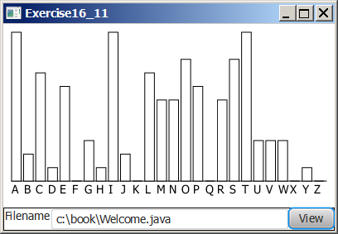

Your Task:
- Place a pane that will display the histogram in the center of the frame.
- Place a label and a text field in a panel, and put the panel in the south side of the frame. The text file will be entered from this text field.
- Pressing the Enter key on the text field causes the program to count the occurrences of each letter and display the count in a histogram.

Your Code:
Copy-paste your code here:

Unable to complete

Screen shots:
Include two screen shots here:

Remember:

You need to complete this file and submit it in related drop box on Blackboard, in addition to uploading your codes in your git repository, before deadline.

